EU biofuels significantly harming food production in developing countries
EU biofuels 10% targets cause millions of peope to go hungry and increase food prices and landlessness, says report.
John Vidal guardian.co.uk, Monday 15 February 2010
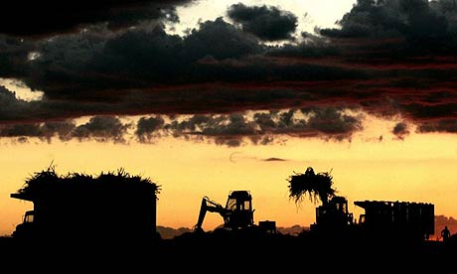
Trucks are loaded with sugar cane, which will be used to produce biofuels, in Brazil, but a new report by ActionAid says biofuels are taking away vital land for food production in developing countries, and are sending millions hungry. Photograph: Paulo Whitaker/Reuters
EU companies have taken millions of acres of land out of food production in Africa, central America and Asia to grow biofuels for transport, according to development campaigners. The consequences of European biofuel targets, said the report by ActionAid, could be up to 100 million more hungry people, increased food prices and landlessness.
The report says the 2008 decision by EU countries to obtain 10% of all transport fuels from biofuels by 2020 is proving disastrous for poor countries. Developing countries are expected to grow nearly two-thirds of the jatropha, sugar cane and palm oil crops that are mostly used for biofuels.
"To meet the EU 10% target, the total land area directly required to grow industrial biofuels in developing countries could reach 17.5m hectares, over half the size of Italy. Additional land will also be required in developed nations, displacing food and animal feed crops onto land in new areas, often in developing countries," says the report.
Biofuels are estimated by the IMF to have been responsible for 20-30% of the global food price spike in 2008 when 125m tonnes of cereals were diverted into biofuel production. The amount of biofuels in Europe's car fuels is expected to quadruple in the next decade.
The report attributes the massive growth in biofuel production to generous subsidies. It estimates that the EU biofuel industry has already received €4.4bn (£3.82bn) in incentives, subsidies and tax relief and that this could triple to over €13.7bn if the EU meets its 2020 target.
The greatest support to the industry is exemption from excise duties. Duty at the pump is 20 pence less per litre compared to conventional fuels although this exemption due to end in 2010, a change which supermarket Morrisons cited last week as the reason for dropping one of its biodiesel blends. In 2009, the duty on low- sulphur petrol and diesel in the UK was 54.19 pence per litre; for biodiesel and ethanol it was 34.19 pence per litre.
"Biofuels are driving a global human tragedy. Local food prices have already risen massively. As biofuel production gains pace, this can only accelerate," said report author Tim Rice. He added thatbiofuels are not even an answer to climate change: "Most biofuels are worse than the fossil fuels they are supposed to replace." . Large scale biofuel plantations can increase carbon dioxide emissions, either directly by cutting down forests or ploughing up other carbon rich habitats, or indirectly by forcing farmers to move into these areas. Separately, the UK Nuffield Council on Bioethics is currently consulting on the ethics of biofuels – how to ensure a new generation of biofuels don't increase greenhouse gas emissions and take food from the poor to fuel cars.
The ActionAid report says Europe is just one region now greatly increasing the amount of biofuels in transport fuel. Analysis of US farm data last month by the Earth Policy Institute in Washington showed that one-quarter of all the maize and other grain crops grown in the US now ends up as biofuel in cars. The grain grown to produce the fuel in the US in 2009 was enough to feed 330 million people for one year at average world consumption levels.
If all global biofuel government targets are met, says ActionAid, food prices could rise by up to an additional 76% by 2020 with an extra 600 million extra people going hungry - six times as much as European policies alone.
Source: http://www.guardian.co.uk/environment/2010/feb/15/biofuels-food-production-developing-countries

